Plantage Amsterdam by boat - The Golden Age tour

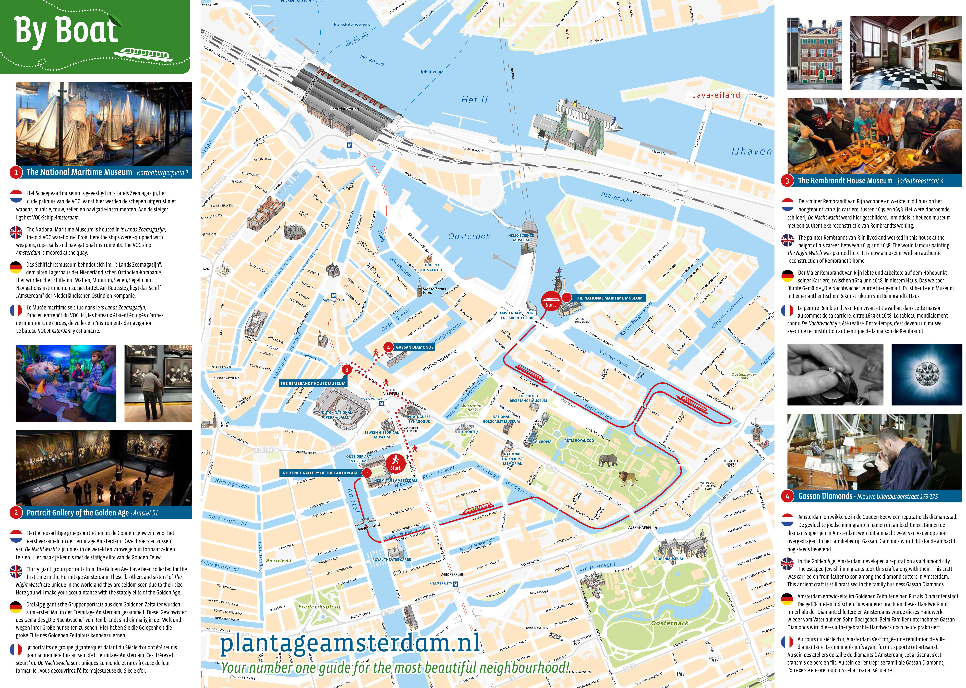

Come on board and discover Amsterdam's Plantage neighbourhood!
A 4-hour cultural highlight tour via boat

The Plantage, also known as "The Cultural Garden of Amsterdam", is located in the eastern part of the city centre and is exceptionally suitable to exploring by boat. Nowhere is there such a high concentration of cultural hotspots - from museums and theatres to the Artis Royal Zoo and a botanical garden. That's why Plantage Amsterdam, in cooperation with the Blue Boat Company, has launched two boat tours to help visitors discover this beautiful neighbourhood!

Starting in the summer of 2016, two 4-hour itineraries - including a boat tour, walk and visits to 3 or 4 locations - will be available for groups of 30 people or more, booked exclusively through tour operators.

The Golden Age
In the Plantage Amsterdam - The Golden Age tour, visitors will discover the Plantage in the era of the Golden Age. After a visit to the National Maritime Museum, a boat will take the group on a 1-hour tour, and visit the Portrait Gallery of the Golden Age, Gassan Diamonds and The Rembrandt House Museum.

Booking Information
- Tours daily between 9:00 and 13:30. The museums on the last part of the tour close at 17:00, so all of the locations can be visited with a start time of no later than 13:30
- Groups of 30 people or more
- Package price: €39,95
- Bookings can be made via reservations@blueboat.nl or phone: +312 679 1370
- Departure point: The National Maritime Museum, Kattenburgerplein 1, Amsterdam.
- Buses may park temporarily at the departure point to allow visitors to embark and disembark. Buses may ONLY park at Gassan Diamonds for the duration of the visit there.

